Toothgrowth Report By Charlie Chen

## Overview

This is a report on the Toothgrowth dataset in R. We will examine which combination of supp and dosage is most beneficial to toothgrowth.

## Report

data("ToothGrowth") ## Loading the ToothGrowth dataset  
names(ToothGrowth) ## Examine the column names

## [1] "len" "supp" "dose"

## Examine the class of each column  
class(ToothGrowth[,1])

## [1] "numeric"

class(ToothGrowth[,2])

## [1] "factor"

class(ToothGrowth[,3])

## [1] "numeric"

head(ToothGrowth) ## Get a peek at the dataset

## len supp dose  
## 1 4.2 VC 0.5  
## 2 11.5 VC 0.5  
## 3 7.3 VC 0.5  
## 4 5.8 VC 0.5  
## 5 6.4 VC 0.5  
## 6 10.0 VC 0.5

summary(ToothGrowth) ## Summary of the data

## len supp dose   
## Min. : 4.20 OJ:30 Min. :0.500   
## 1st Qu.:13.07 VC:30 1st Qu.:0.500   
## Median :19.25 Median :1.000   
## Mean :18.81 Mean :1.167   
## 3rd Qu.:25.27 3rd Qu.:2.000   
## Max. :33.90 Max. :2.000

library(dplyr)

## Warning: package 'dplyr' was built under R version 3.5.3

##   
## Attaching package: 'dplyr'

## The following objects are masked from 'package:stats':  
##   
## filter, lag

## The following objects are masked from 'package:base':  
##   
## intersect, setdiff, setequal, union

grouped <- ToothGrowth %>%   
 group_by(supp, dose) %>% ## Group the data by supp and dose   
 mutate(supp_dose = gsub(' ','_', paste(supp, dose))) ## Add a column that combines column supp and dose  
  
head(grouped)

## # A tibble: 6 x 4  
## # Groups: supp, dose [1]  
## len supp dose supp_dose  
## <dbl> <fct> <dbl> <chr>   
## 1 4.2 VC 0.5 VC_0.5   
## 2 11.5 VC 0.5 VC_0.5   
## 3 7.3 VC 0.5 VC_0.5   
## 4 5.8 VC 0.5 VC_0.5   
## 5 6.4 VC 0.5 VC_0.5   
## 6 10 VC 0.5 VC_0.5

grouped_summary <- ToothGrowth %>%   
 group_by(supp, dose) %>% ## Group the data by supp and dose   
 summarize_all(mean) %>% ## Get the mean of each group  
 mutate(supp_dose = gsub(' ','_', paste(supp, dose))) ## Add a column that combines column supp and dose  
  
grouped_summary

## # A tibble: 6 x 4  
## # Groups: supp [2]  
## supp dose len supp_dose  
## <fct> <dbl> <dbl> <chr>   
## 1 OJ 0.5 13.2 OJ_0.5   
## 2 OJ 1 22.7 OJ_1   
## 3 OJ 2 26.1 OJ_2   
## 4 VC 0.5 7.98 VC_0.5   
## 5 VC 1 16.8 VC_1   
## 6 VC 2 26.1 VC_2

barplot(grouped_summary$len, ylab = 'tooth growth', names.arg = grouped_summary$supp_dose, col = 'blue') ## barplot the tooth growth vs supp + dose used

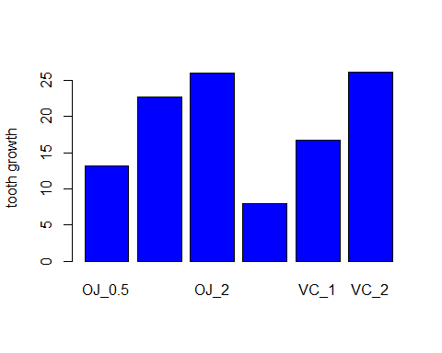

## From the graph, we can see pretty clearly that using dosage of 2 is the way to go, regardless if you use OJ or VC, since OJ_2 and VC_2 have the same amount of toothgrowth.  
  
## We are, however, interested in if OJ_2 outperforms OJ_1 by a statistically significant margin  
## So we perform a t test, assuming unequal variance and alpha = 0.05  
t.test(grouped$len[grouped$supp_dose == 'OJ_2'], grouped$len[grouped$supp_dose == 'OJ_1'], alternative = "greater", var.equal = FALSE)$p.value

## [1] 0.01959757

## Conclusion

We can see from the graph and the t-test that using a dosage of 2 is the way and only way to go if you are looking for maximum tooth growth. OJ_2 and VC_2 exhibit the same amount of toothgrowth while OJ_2 outperforms OJ_1 by a statistically significant (assuming alpha = 0.05 and unequal variance for the two sets of data) margin.